Tender Number: | 2 – 2024 2025
Tender Title: | RFT 2 – 2024/25 – Culvert Replacement, Brooking Street, Williams
Tender Description: | Design, Supply and Installation of Culvert System at Brooking Street, Williams
Tender Opened in the Presence of: | Name: Peter Stubbs  Name: Tony Kett
Tender Deadline Date and Time: | 7/1/2025 at 4:00pm
Tender Opening Date and Time: | 8/1/2025 at 9:30am

Tenderers
1 | Simms Civil ($350,560.10)
2 | Neo Civil ($1,322,029.23)
3 | Castle Civil ($428,683.75)
4 | DCL Contracting ($1,

Advertisement Details: | West Australian
Advertisement Notice: | 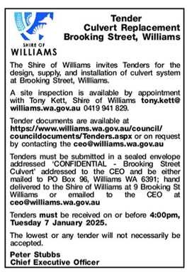

Tender Awarded By: | CEO under delegated authority
Date of Council Meeting/CEO Award: | 19th February 2025
Council Resolution:

Successful Tenderer(s): | Simms Civil
Value of Successful Tender: | $350,560.10

