Tender Number: | 1 – 2024 2025
Tender Title: | RFT 1 – 2024/25 - Excavator
Tender Description: | For Sale by Tender – Volvo EC210 BLC Excavator
Tender Opened in the Presence of: | Name: Peter Stubbs  Name: Tony Kett
Tender Deadline Date and Time: | 9/12/2024 at 4:00pm
Tender Opening Date and Time: | 10/12/2024 at 9:30am

Tenderers
1 | HA & SA Panizza & Co

Advertisement Details: | West Australian 16/11/2024
Advertisement Notice: | 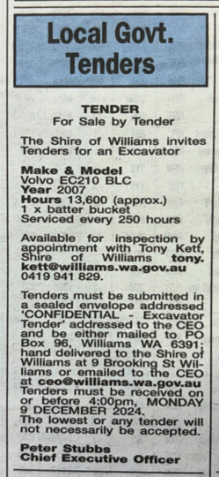

Tender Awarded By: | Council
Date of Council Meeting/CEO Award: | 18th December 2024
Council Resolution: | 57/25

Successful Tenderer(s): | HA & SA Panizza & Co
Value of Successful Tender: | $30,000 plus GST

