

Public Health Plan

2025–2030

CONTENTS
Executive Summary 2
Legislative and Policy Context 2
1. Introduction 2
2. Population Profile 2
3. Key Health Risk Factors 3
4. Injury and Transport Safety 5
5. Environmental Health 6
6. Healthcare Access 7
7. Emergency Preparedness 7
8. Community Infrastructure & Services 7
9. Strategic Priority Areas 8
10. Implementation and Monitoring 9
Key Areas of Concern 10
Conclusion 10

Executive Summary
The Public Health Plan (PHP) for the Shire of Williams provides a strategic framework to protect, promote, and improve the health and wellbeing of the community between 2025 and 2030. Developed in accordance with the Public Health Act 2016 (WA), the Plan identifies key public health issues, risks, and priority areas for action.
Using regional and state health data, the Plan highlights major community health challenges and outlines practical strategies that the local government can implement to improve population health outcomes. It supports a coordinated approach with state agencies, community organisations, and other stakeholders.
The Plan emphasises prevention, equity, environmental health, and community resilience, recognising the social, environmental, and economic factors that influence community health and wellbeing.

Legislative and Policy Context
This Plan has been developed under:
- Public Health Act 2016 (WA) – Part 5: Public Health Planning
- State Public Health Plan for Western Australia
- WA Health Strategic Intent
- Shire of William Strategic Community Plan
- Local Planning Strategy and Corporate Business Plan

1. Introduction
The purpose of this Public Health Plan is to provide a strategic framework to improve community health and wellbeing across the Shire of Williams. The plan identifies current health trends, environmental health risks, and opportunities for prevention through infrastructure, services and community initiatives.

2. Population Profile
The Shire of Williams has a population of approximately 1,063 residents according to the 2024 Census conducted by the Australian Bureau of Statistics. The median age of residents is 41 years, which is slightly higher than the Western Australian median age of 38 years. Approximately 18.8% of the population is aged 65 years and over, indicating a gradually ageing population. The average household size is 2.4 persons and the labour force participation rate is approximately 67.5%, slightly above the Western Australian state average.
These demographic characteristics highlight the importance of maintaining accessible healthcare services, injury prevention initiatives, and healthy ageing programs within the community.
Population (2024 est): 1,063 residents
Median age: 41
Aboriginal population: 1.9%
Residents born overseas: 24.8%
Languages other than English spoken at home: 17.1%

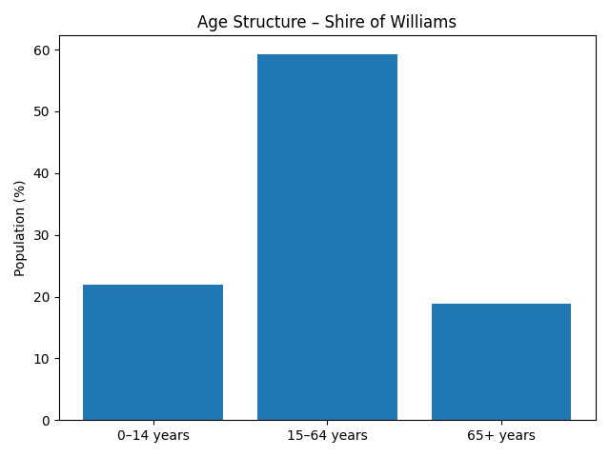

3. Key Health Risk Factors
Overweight and Obesity
Overweight and obesity rates among both children and adults are a significant health concern in Australia.
- Childhood overweight and obesity rates are slightly higher than WA averages.
- 39.7% of adults are classified as obese, higher than the WA average of 37.3%.
These conditions increase the risk of chronic diseases including:
- cardiovascular disease
- type 2 diabetes
- some cancers
Lifestyle behaviours such as low vegetable consumption and insufficient physical activity contribute to these outcomes. Health data from the Department of Health, Epidemiology Directorate, Public and Aboriginal Health Division, Department of Health WA, January 2026 highlights several behavioural and lifestyle risk factors contributing to chronic disease risk in the Shire of Williams.

Sugar-Sweetened Beverage Consumption Among Children
Sugar-sweetened drink consumption among children is higher than the WA average:
- Williams: 11.5%
- WA: 8.5%
High consumption of sugary drinks contributes to:
- childhood obesity
- dental disease
- increased long-term risk of chronic disease
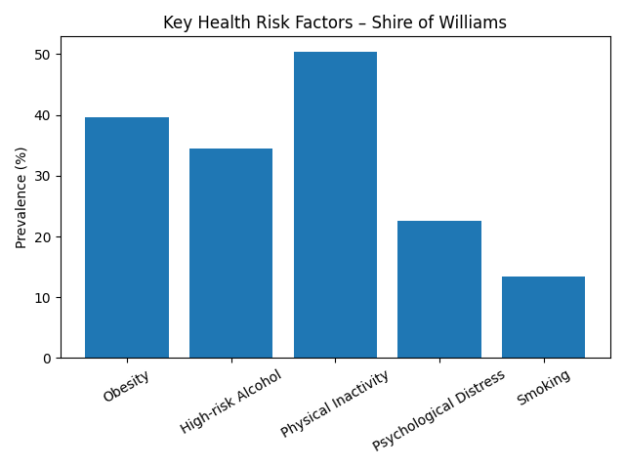
Health promotion targeting children and families may assist in reducing consumption.

4. Injury and Transport Safety
Transport-Related Injuries
Transport accidents represent the most significant injury-related concern for the Shire of Williams.
Hospitalisation rates for transport accidents are higher than the Western Australian average:
- Williams: 409.4 per 100,000
- WA: 236.9 per 100,000
Rates are particularly high among male residents (543.8 per 100,000).
This reflects the rural nature of the Shire, where residents rely heavily on private vehicles and frequently travel long distances on regional roads and highways. Road safety therefore remains a key public health priority.
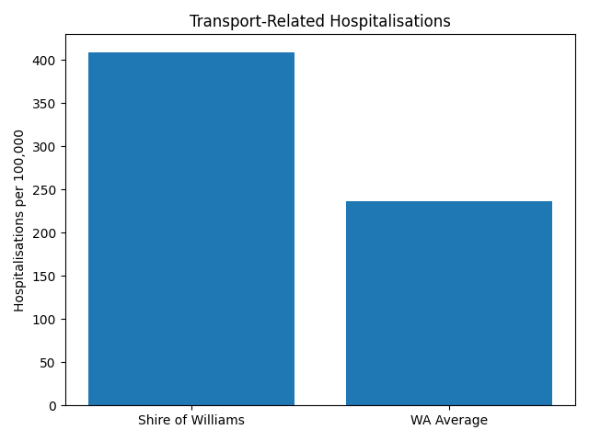

Injury-Related Deaths – Key Points
- Injury-related mortality remains an important indicator of community health and safety.
- Data from 2012–2021 shows several injury trends affecting the Shire of Williams.
- Falls: Age-standardised mortality rate (ASR) approximately 13.8 per 100,000, similar to the Western Australian average.
- Assault: Mortality rate approximately 0.9 per 100,000, similar to the state average.
- Transport-related deaths: Higher than the WA average (14.5 vs 7.2 per 100,000), indicating increased road safety risks in rural environments.
- Intentional self-harm: Higher than the WA average (17.1 vs 13.5 per 100,000), highlighting the importance of mental health support services.
- Rural factors such as long travel distances, high-speed roads, and limited access to emergency services may contribute to transport injury risks.
- An ageing population increases the likelihood of falls and injury, particularly among residents aged 65 years and over.
- Limited access to allied health and specialist services in rural areas may impact early treatment and prevention programs.

Implications for Public Health Planning
- Strengthen road safety awareness and infrastructure improvements.
- Support mental health promotion and suicide prevention initiatives.
- Promote healthy ageing and falls prevention programs.
- Improve access to healthcare services through regional partnerships.
- Maintain strong emergency response capacity through St John Ambulance and local services.

5. Environmental Health
Vector-borne diseases are an identified public health concern within the Shire of Williams. To reduce the risk of mosquito-borne illnesses such as Ross River and other viruses, the Shire will continue to implement mosquito monitoring and control measures.
Actions
- Conduct mosquito fogging programs when required to manage mosquito populations.
- Monitor potential mosquito breeding areas including wetlands and standing water.
- Provide community education on mosquito bite prevention and personal protection.
- Work with relevant state agencies where necessary to manage mosquito-related risks.
These activities support the prevention of mosquito-borne disease and protect public health in the Williams town.

6. Healthcare Access
Access to primary healthcare services can be limited in rural communities. The Shire of Williams continues to support partnerships that improve access to healthcare for residents.
Actions
- Support the availability of a subsidised General Practitioner service operating one day per week in Williams.
- Continue partnership arrangements with St Luke’s Medical Centre in Katanning to provide medical services to the Williams community.
- Promote awareness of available health services within the region.
Improving access to primary care supports early intervention and reduces the burden on emergency health services.

7. Emergency Preparedness
The availability of emergency medical response services is essential in rural communities where travel distances to hospitals can be significant.
Actions
- Continue to support the presence and operation of St John Ambulance services within the Shire of Williams.
- Promote community awareness of emergency services and emergency contact procedures.
- Encourage community participation in first aid training programs where available.
- Partnership support to the Community Assisted Transport Service (CATS) coordinated by the Shire of Narrogin and designed to assist people access specialised health services elsewhere.
These services play a critical role in emergency response and community safety.

8. Community Infrastructure & Services
Investment in recreational infrastructure supports improved physical activity, mental health, and community wellbeing. The Shire proposes the development of a new indoor multi-use sporting court within the designated financial year.
Shire maintains and supports a range of community infrastructures for these reasons. Examples include footpaths and walking trails, street lighting, parks and playgrounds, sporting facilities, halls, library and childcare services.
The Shire of Williams supports a range of community initiatives that promote health including mental and health and wellbeing. Examples include the;
- Community Resource Centre to operate the night markets, reading programs, annual seniors luncheon, Evolve event for rural women.
- Various support for Vac Swim, repertory, and other not for profit groups and activity.

9. Strategic Priority Areas

Priority Area | Key Action | Outcome
Mosquito Control | Fogging, surveillance and larvicide programs | Reduced vector-borne disease risk
Emergency Response | Install and maintain AED’s in council buildings and train staff | Improved cardiac emergency survival
Healthcare Access | Support weekly subsidised GP clinic | Improved rural healthcare access
Road Safety | Community road safety awareness and infrastructure review | Reduced transport injuries
Active Lifestyle | Develop indoor sporting court and promote recreation | Increased physical activity

10. Implementation and Monitoring
The Shire of Williams will implement the following actions over the life of the Public Health Plan to address identified health priorities and improve community wellbeing. The implementation plan outlines key actions, responsible stakeholders and indicative timeframes.
Public Health Priority | Action | Responsible Agency | Timeframe
Mosquito and Vector Control | Undertake mosquito monitoring and fogging where required to reduce mosquito populations | Shire of Williams Environmental Health | Usually in the Spring months
Mosquito and Vector Control | Provide community information regarding mosquito bite prevention and vector-borne diseases | Shire of Williams | Ongoing but increasing in the Spring period
Emergency Preparedness | Maintain Automated External Defibrillators (AEDs) in all Council buildings | Shire of Williams | Short–Medium Term
Emergency Preparedness | Conduct annual testing and maintenance of defibrillators | Shire of Williams | Annually
Emergency Preparedness | Maintain stocked first aid kits in all Council facilities | Shire of Williams | Ongoing
Emergency Preparedness | Ensure staff receive appropriate first aid and emergency response training | Shire of Williams | Ongoing
Health Services Access | Support subsidised GP services available in Williams one day per week | Shire of Williams / St Luke’s Medical Centre, Katanning | Ongoing
Emergency Medical Services | Support the of St John Ambulance services in Williams | Shire of Williams / St John Ambulance | Ongoing
Water Safety | Maintain partnership with Water Corporation to ensure safe and reliable drinking water supply. And use old, recycled water on sporting fields and parks | Water Corporation / Shire of Williams | Ongoing
Physical Activity and Recreation/Mental Health | Maintain and support local sporting and recreational facilities | Shire of Williams | Ongoing
Physical Activity and Recreation/ Mental Health | Develop a new indoor sporting court to encourage physical activity and community participation | Shire of Williams | Upcoming Financial Year
Food Safety | Inspection of food registered business operating within the Shire of Williams | Shire of Williams- uses the Shire Narrogin Environmental Health Officer under an MOU | Ongoing- frequency dependent on the risk category of each business
Road Safety | Promote road safety awareness in collaboration with state agencies. | Shire of Williams / WA Government | Ongoing

Key Areas of Concern

• High transport-related hospitalisation rates compared to WA.
• Above State average prevalence of physical inactivity among adults.
• Above State average obesity rates.
• Elevated vector-borne disease notifications.
• Limited access to local primary healthcare services.

Conclusion
The Shire of Williams Public Health Plan provides a strategic framework to guide actions that support the health and wellbeing of the local community.
By focusing on key public health priorities, including injury prevention, mosquito control, access to healthcare services, emergency preparedness, and promotion of healthy lifestyles, the Shire aims to create a safe, healthy and resilient community.
Ongoing collaboration with health services, government agencies, community organisations and residents will be essential to successfully implement this plan and improve long-term health outcomes for the Williams community.
Document Control:
Created March 2026

