DEED OF AGREEMENT TO ACCESS COMMUNITY WATER SUPPLY

Parties to Agreement
The Shire of Williams (Shire) located at: 9 Brooking Street, Williams WA 6391

AND:

Williams Golf Club Inc. (Club) located at: 12587 Albany Highway, Williams WA 6391

Purpose
- The purpose of this Agreement is to formalise the arrangements whereby water can be supplied and taken for the purpose of stock watering, fire suppression and road construction works from land identified as being Lot 1160 on Plan 104171 and Lot 2264 on Plan 112010 Albany Highway, Williams as marked on the Landgate images on Page 4 of this document (the Land).

Objective
- The objective of the Agreement is to document between the parties that the Shire wishes to have access to bore water and water storage infrastructure on land owned by the Club and for the arrangements to be clearly identified in a list of obligations on the parties.

Background
- The Shire was successful in obtaining a grant from the Department of Water and Environmental Regulation for a project under the Community Water Supply Program to construct water storage tanks and connect those tanks to an existing bore installed on the Land.

- The project includes the installation of a submersible pump in the bore and pipework from the bore to the tanks. In addition, an electric pump is installed at the tanks for the purpose of filling vehicles. Both the submersible pump and electric pump are provided power from new connections made to the Club’s Clubhouse building.

- The Club installed a bore on Lot 2264 on Plan 112010 in 2016 and the cost of this is accepted as an in-kind contribution by the Club to the project.

- The Community Water Supply Program aims to encourage the establishment of reliable non-potable water supplies to meet emergency farmland water needs and reduce scheme water use.

- Water sourced from the tanks for stock watering and fire suppression is available to the community and access is provided from the Albany Highway using the Club’s principal access road.

- Water is not available to property owners outside the Shire of Williams and not available for ‘commercial’ farming activities, i.e., intensive agriculture, without the agreement of the parties to this agreement.

- Water sourced from the tanks for roadworks will only be by the Shire of Williams.

Obligations of the Shire:
- Will meet all costs associated with maintaining the infrastructure, including tanks, pumps and pipework connections.

- Will maintain the entrance road, to a rural road standard, from the Albany Highway to the hardstand area/turnaround for filling of vehicles.

- Will remove the tank and pump infrastructure in the event that the bore fails (unless otherwise agreed).

- Supply fencing material and gates for the installation of a secure area for general access to the tanks, separate from the Clubhouse.

- Waiver of 150 hours of labour and related machine hours for mowing of fairways at the Williams Golf Club, per golf season, for the duration of the agreement. Labour hours and machine hours more than this amount will be charged to the Club at cost recovery. Hours will be charged/accrued from the Shire depot (mobilisation) to return to the Shire depot (demobilisation).

- Allow the Club access to water from the tanks for stock watering.

Obligations of the Club:
- Will allow access to the land from the Albany Highway to the hardstand area/turnaround for filling of vehicles.

- Install fencing on the access road to the location of the tanks and install gates to secure access to the Clubhouse.

Mutual Obligations of both parties:
- They will use their best endeavours and fully cooperate to provide a long-term viable source of water within the capacity of the underground supply.

- They agree that access to the land and the water supply will commence on the commissioning of the infrastructure.

Term of Agreement:
- This agreement will have a term of five (5) years commencing on the 30 day of April 2026 and conclude on the 30 Day of April 2030.

- There is nothing preventing the parties from entering into a new agreement at the expiration of the term or varying the agreement by mutual consent.

This Agreement, dated 16 Day of April 2026 , is executed as a Deed and is witnessed as follows:

The Williams Golf Club:

……………………………
Vice President

Witness

Witness Name & Address

Shire of Williams:

………………………..
President

Witness

Witness Name & Address

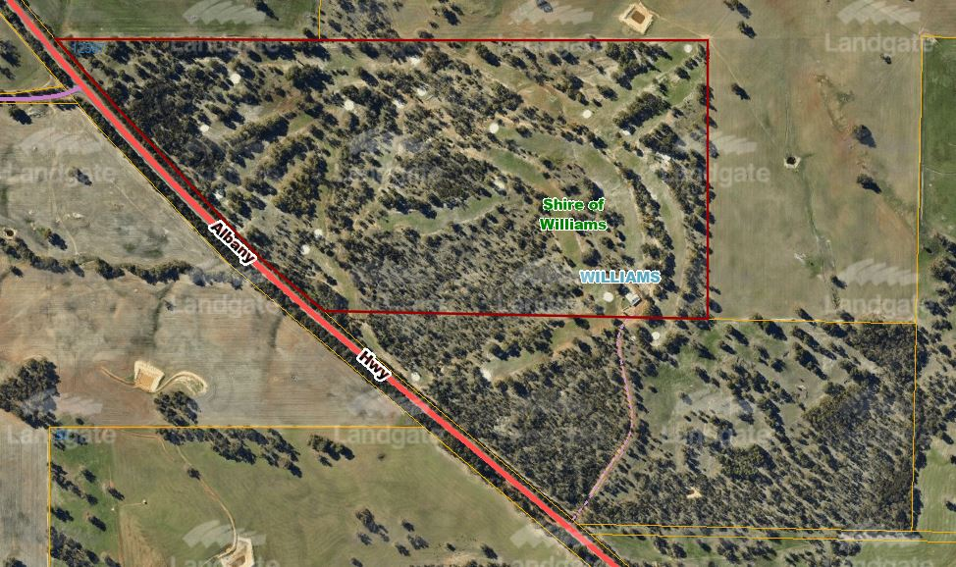
Tanks
Bore
Lots 1160 and 2264 Albany Highway – Williams Golf Club

